Author Bios and Photos

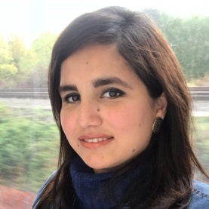

FATIMA SAJID BUTT is a doctoral candidate for Engineering Informatics at the University of Cádiz, Spain, and a research assistant at Frankfurt University of Applied sciences, Frankfurt, Germany.

She received her Bachelor in Information Technology from the University of the Punjab, Lahore, Pakistan, and her Masters in High Integrity Systems (HIS) from Frankfurt University of Applied Sciences, Germany in 2010 and 2019 respectively. She is a part of the research group Industrial Data Sciences (INDAS) along with Jörg Schäfer, Matthias Wagner, and Dirk Stegelmeyer at Frankfurt University of Applied Sciences, Germany.

Her research interests include time series analysis for classification and application of machine learning algorithms for industrial problems such as predictive maintenance.

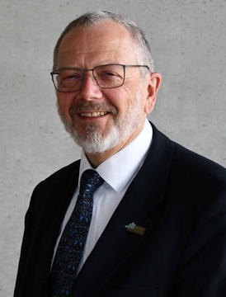MATTHIAS WAGNER received a Diploma and a Dr. rer.nat. in Physics from the Johannes Gutenberg- Universität Mainz (Germany). He was head of Measuring Technology Software Development at Hottinger Baldwin Messtechnik (HBM) in Darmstadt (Germany) from 1990 until 2002. In 2002, he was appointed as Professor of Computer Science at the Frankfurt University of Applied Sciences in Frankfurt am Main (Germany). Since 2005, he has been the Program Director of the international M.Sc. program “High Integrity Systems”. From 2017 to March 2020, he served as Vice-Dean for Research and International Relations of the

FB2, Department of Computer Science and Engineering. Since 2010, he has been head of the Research Group Wireless Sensor Networks and Internet of Things (WSN & IoT). His research interests cover safety-critical computer systems, smart sensors and actuator networks, Software and Systems Engineering

and Computational Science is supported by research stays at the UCASE Software Engineering Research Group of the Universidad de Cádiz (Spain) and the Dipartimento di Fisica e Astronomia of the Università degli Studi di Firenze (Italy).

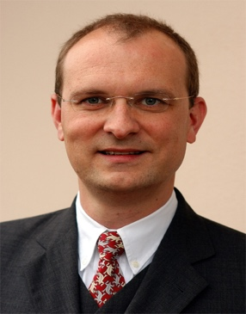JÖRG SCHÄFER (M’12-22) is a professor of Computer Science at the Frankfurt University of Applied

Sciences. He received his Ph.D. degree from Bochum University (Germany) in Mathematical Physics in 1992. After spending more than 10 years working as a principal architect in IT consulting for large international companies he was appointed as a full professor of Computer Science at Frankfurt University of Applied Sciences in 2009. Since 2012 he served as the chairman of the computer science B.Sc. program. His main research interest is in the theoretical understanding of deep learning architectures and applying machine learning and probabilistic models in ubiquitous computing applications. He runs a research group on human activity recognition (HAR) and channel state information (CSI) and jointly with Matthias Wagner and Dirk Stegelmeyer the research group industrial data science (INDAS). He is collaborating with UCASE Software Engineering Research Group of the Universidad de Cádiz (Spain).

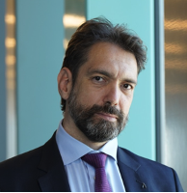 DAVID G MEZ-ULLATE received his Ph.D. in Physics from Universidad Complutense de Madrid in 2001. He is a Distinguished Researcher at the University of Cádiz, where he founded and serves as Director of UCA Datalab. He is a Professor of Applied Mathematics on leave from Complutense University of Madrid, an Adjunct Professor at IE Business School, and Visiting Professor of Mathematics and Data Science at the University of Loughborough (United Kingdom). His research interests span a wide range of topics, ranging from mathematical physics and approximation theory to applied machine learning and data science. His major contribution is the theory of exceptional orthogonal polynomials, which has earned him international recognition expressed as plenary talks in the main conferences of the field and invited seminars at Cambridge, Harvard, Edinburgh, Stockholm, Copenhagen, and Rome, among others.

For the past 10 years, he has specialized in knowledge transfer of mathematics to industry. He is currently President of the Knowledge Transfer Commission of the Royal Spanish Mathematical Society, and a member of its Governing Board. In 2016 he received a Leonardo Scholarship from the BBVA Foundation for a project on credit card fraud detection. He has coordinated 8 knowledge transfer contracts with industry in the financial, fisheries, biomedical, legal tech, and aeronautical sectors. He is co-founder and scientific advisor of the technological start-up Komorebi AI.